Student Minds Under Pressure: Mental Health and Career Anxiety
Miss. Rohini Prashant Ghogare
(Student of R. C. Patel Institute of Management Research and Development, Shirpur)
Miss. Prerna Ganesh Dhakare
(Student of R. C. Patel Institute of Management Research and Development, Shirpur)

Abstract:
Today, students are facing a lot of pressure because of studies, exams, and future career decisions. Competition is increasing day by day and students feel stressed about getting good marks and jobs. Many students suffer from stress, anxiety, fear of failure, and depression due to academic pressure and career uncertainty.
This study focuses on understanding the mental health problems of students and how career anxiety affects their life. The study explains the main reasons for stress such as heavy academic workload, parental pressure, peer competition, and lack of proper career guidance. Poor mental health affects students’ concentration, confidence, academic performance, and personal life.
The study also highlights the importance of counselling, mental health awareness, and career guidance programs in educational institutions. It concludes that supporting students mentally is very important for their overall development and future success.

Keywords: Student Mental Health, Career Anxiety, Academic Stress, Psychological Well-being

Introduction:
Mental health is one of the most important parts of a student’s life. [1] It affects how students think, feel, and perform in their studies. In the past, mental health problems in students were less discussed openly. Many students silently suffered from stress and anxiety, but there were very few studies, awareness programs, or counselling services available in schools and colleges. In older times, students who faced pressure of studies were often told to “study more” or “don’t worry”, so many problems were ignored or not taken seriously. True evidence of student depression and anxiety was seen in the early 2000s when some research studies started reporting increased stress, sleep problems, lack of concentration, and emotional breakdowns among students. [4]
In recent years, especially after competitive exams became more difficult and career opportunities became uncertain, mental health issues among students increased rapidly. Studies and surveys have shown that more students today experience stress, anxiety, depression, and fear of failure than before. [5] Many students feel overburdened by heavy academic workload, exam pressure, parental expectations, comparison with peers, and social media influence.[2] Due to this pressure, students face sleep problems, mood swings, loss of interest in studies, low self-confidence, and sometimes even thoughts of giving up. [3]

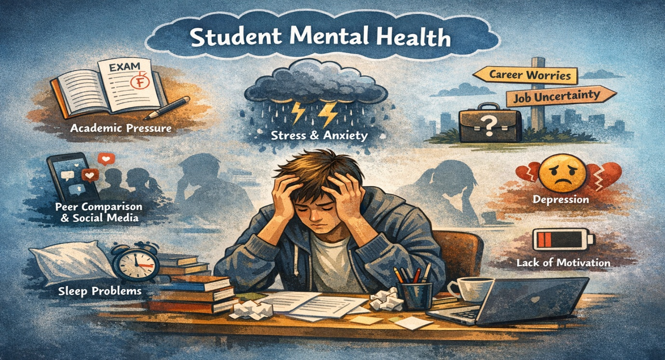
Figure No. 1: Factors Influencing Student Mental Health
Today, the worry about future careers has become a major part of student life. With limited job opportunities, changing technology, and highly competitive markets, students often feel confused or insecure about their future. [5] Many students fear choosing the wrong career path, which increases their anxiety. Mental health problems have now become a serious concern in schools and universities. [4] In some cases, students even face depression and severe stress because they do not get proper support or guidance when needed.
In the future, if student mental health is not improved, the situation may become worse. As competition continues to grow and more students enter the job market every year, mental health problems may increase further. If students do not get enough counselling, emotional support, and career guidance, then issues like burnout, depression, stress-related illnesses, low productivity, and lack of motivation may rise. Future workplaces will also require mentally strong workers, so if mental health of students is weak today, tomorrow’s workforce may struggle with problems related to confidence, decision-making, and performance. [1]
Because of all these reasons, studying student mental health and career anxiety is very important. By understanding the causes and effects of pressure on student we can find better ways to support them. This study tries to show how academic pressure and career anxiety affect students’ mental health, and suggests ways to help students feel better, perform well, and build a positive future.

Objectives:
- To understand the concept of mental health among students.
- To identify causes of academic pressure and career anxiety.
- To study the impact of mental health problems on academic performance.
- To analyses the relationship between career uncertainty and anxiety.
- To identify common mental health issues like stress and depression.
- To study the role of parents, teachers, and institutions in reducing stress.
- To understand coping strategies used by students.
- To suggest measures for improving mental health awareness and career guidance.

Hypothesis:
• Stress and Anxiety Have a Significant Impact on Students’ Mental Health and Academic Performance.
• Support Measures Like Career Guidance, Counselling Services, Reduced Academic Pressure, and Stress-Management Activities Significantly Help in Reducing Student Stress and Career Anxiety.

Research Methodology:
The research was conducted among college students in Maharashtra to understand mental health concerns and anxiety related to career and job competition. The study focused on identifying the level of stress, emotional challenges, and factors influencing students’ psychological well-being.
A structured questionnaire was designed and distributed to students to collect primary data. The questionnaire included questions related to stress levels, career pressure, academic challenges, and coping mechanisms.
The total sample size for the study was 117 respondents, ensuring a reliable representation of students’ perspectives.
The data collected focused on:
• Stress and anxiety related to job market competition
• Academic pressure and performance issues
• Mental health challenges among students
• Awareness and support systems for stress management
To analyses the data and test the hypotheses, the Chi-Square (χ²) test was applied at a 0.05 significance level (95% confidence level) to determine whether career competition significantly influences anxiety levels among students.

Hypothesis 1:
Stress and Anxiety Have a Significant Impact on Students’ Mental Health and Academic Performance.
Thus, applying the formula: X² = ∑ (Oi-Ei)2 / Ei

Sr No | Mental Health Issues Due to Stress | Oi | Ei | Oi-Ei | (Oi-Ei) ² | (Oi-Ei) ²/Ei
1 | Lack of Concentration | 40 | 30 | 10 | 100 | 3.33
2 | Low Confidence | 32 | 30 | 2 | 4 | 0.13
3 | Mood Swings | 25 | 30 | -5 | 25 | 0.83
4 | Sleep Problems | 23 | 30 | -7 | 49 | 1.63
 | Total | 120 |  |  |  | 6.20
Where:
• Oᵢ = Observed Frequency (Actual Survey Responses)
• Eᵢ = Expected Frequency (Predicted Responses)
Showing Calculation of ∑ (Oi-Ei)2 / Ei in Maharashtra State.
∑ (Oi-Ei) ² / Ei = 6.20
The Tabulated (Critical) Value Of Χ² For a Degree of Freedom (D.F.) = 3 Depends on The Chosen Significance Level (Α). Here Are the Common Values:
Χ² = 9.488
X² = 6.20 < 9.488

Result:
Since the calculated value (6.20) is less than the tabulated value (9.488), the null hypothesis is rejected, and the alternative hypothesis (H1) is accepted.
Therefore, stress and anxiety significantly affect students’ mental health and academic performance. Many students reported lack of concentration, low confidence, mood swings, sleep problems, and academic difficulties due to stress.

Hypothesis 2:
Think competition in the job market increases your anxiety.
Thus, apply the formula:
X^2=∑(Oi-Ei) ^2/Ei

Sr No | Think competition in the job market increases your anxiety. | Oi | Ei | Oi-Ei | (Oi-Ei)² | (Oi-Ei)²/Ei
1 | Yes | 84 | 39 | 45 | 2025 | 51.92
2 | No | 12 | 39 | -27 | 729 | 18.69
3 | Not Sure | 21 | 39 | -18 | 324 | 8.30
 | Total | 117 |  |  |  | 78.28

Where:
• Oᵢ = Observed Frequency (Actual Survey Responses)
• Eᵢ = Expected Frequency (Predicted Responses)
Showing Calculation of ∑ (Oi-Ei)2 / Ei in Maharashtra State.
∑ (Oi-Ei) ² / Ei = 78.28
The Tabulated (Critical) Value Of Χ² For a Degree of Freedom (D.F.) = 2 Depends on The Chosen Significance Level (Α). Here Are the Common Values:
Χ² = 5.991
X² = 78.28 > 5.991

Result:
Therefore, our hypothesis stating that competition in the job market increases anxiety has been validated. The chi-square test result (χ² = 78.28, df = 2, p < 0.05) shows a significant difference between the expected and actual responses. This indicates that anxiety related to job market competition is not due to chance but is a real and measurable concern.
In Maharashtra, many students and job seekers reported feeling anxious due to intense job competition. This proves that increasing competition for employment opportunities is a major psychological stress factor, affecting confidence, mental well-being, and career decision-making. Thus, the findings confirm that job market competition has a significant impact on anxiety levels among students and job seekers.

Experiment:
- What is the main source of academic stress ?
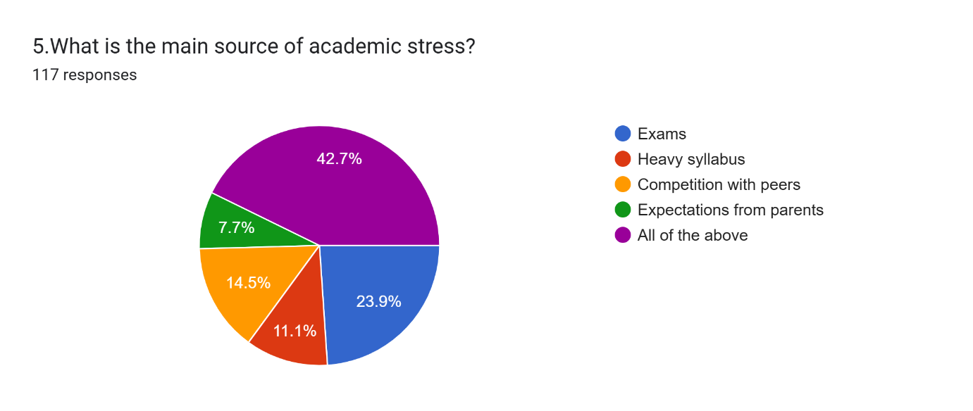

- How often do you feel stressed about your academic performance?
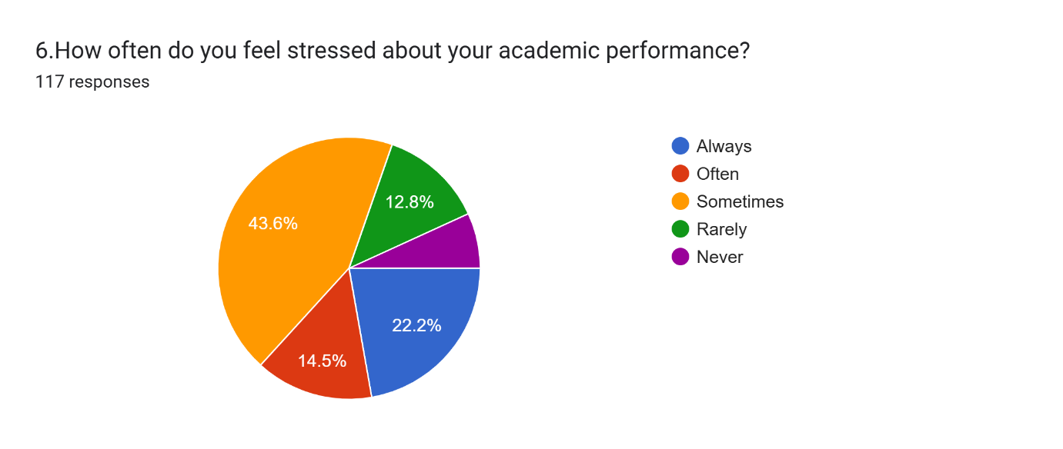

- Do you feel anxious about your academic performances?

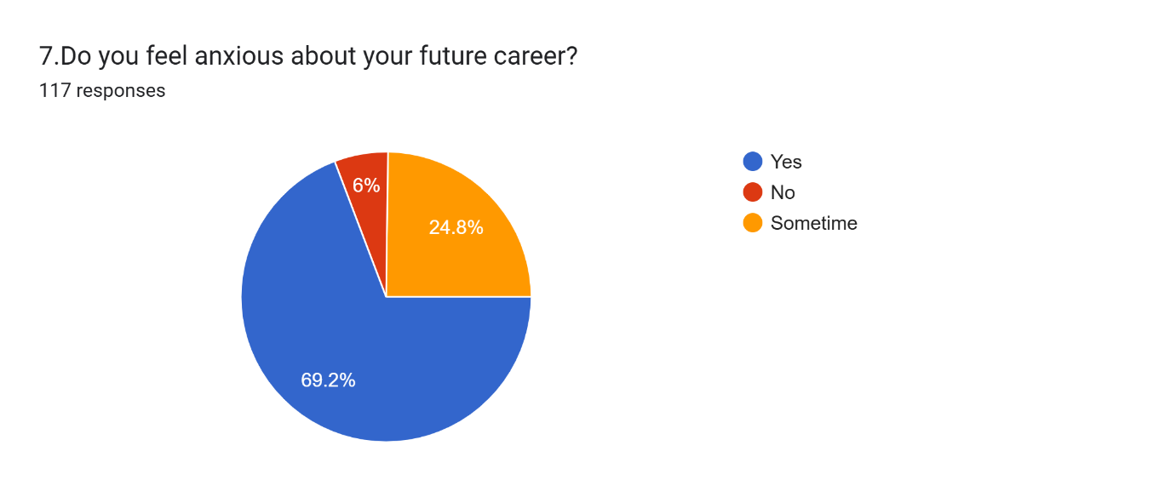

- Do you think competition in the job market increases your anxiety?
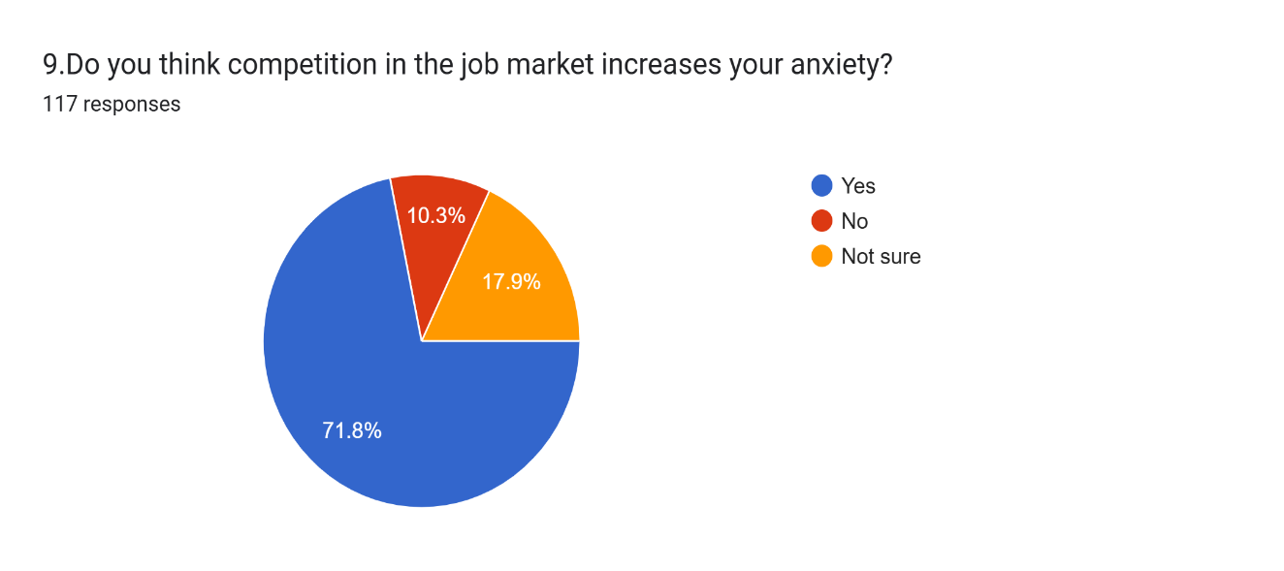
- Do you receive emotional support from family or friends?

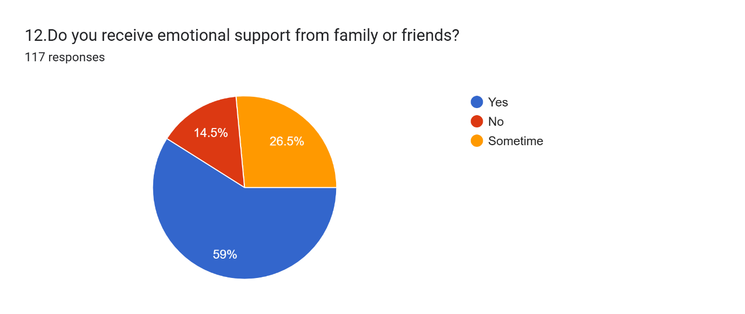

- What measures can help reduce student stress and career anxiety?
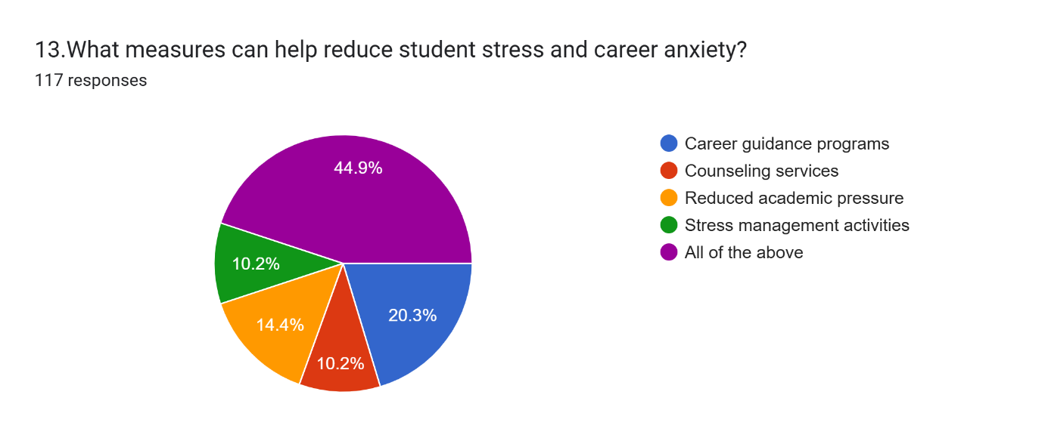

Findings:

Objective 2: To Identify Causes of Academic Pressure and Career Anxiety After analyzing the responses collected from students, the study found that academic workload, high expectations from parents, fear of failure, and intense job market competition are the major causes of academic pressure and career anxiety. [5] In Maharashtra, most respondents indicated that uncertainty about future career opportunities and increasing competition significantly increase stress levels. A large proportion of students reported feeling anxious about securing jobs and meeting academic expectations. The findings confirm that academic pressure and career uncertainty are key contributors to students’ anxiety, affecting their emotional stability and confidence.

Objective 5: To Identify Common Mental Health Issues like Stress and Depression
After analyzing the data related to mental health concerns, the study identified several common issues affecting students, including lack of concentration, low confidence, mood swings, sleep problems, and stress-related emotional disturbances. [3] Most respondents reported experiencing one or more of these problems due to academic and career pressure. The findings confirm that stress and anxiety manifest in multiple psychological and behavioral symptoms that impact students’ well-being and daily functioning. These results highlight the growing mental health challenges among students and emphasize the need for timely support and awareness initiatives.

Conclusion:
Mental health and career anxiety are serious problems among students today. [1] Academic pressure, career uncertainty, and parental expectations increase stress levels. Poor mental health affects students’ academic performance and confidence.
Providing counselling, career guidance, and a supportive environment is essential. [5] Educational institutions, parents, and teachers must work together to support students’ mental well-being and overall development.

References:
- World Health Organization (2022). Mental Health of Students.
- Deb, S., Strodl, E., & Sun, J. (2015). Academic stress and mental health.
- Kumar, S., & Bhakra, J. P. (2013). Stress and coping strategies of students.
- Eisenberg, D., Hunt, J., & Speer, N. (2013). Mental health in college students.
- OECD (2021). Student Well-being and Mental Health.

